**LINK**

<https://www.meetyourproperty.ph>

**PURPOSE**

The MYP Website is not a full fledge web application which stores and retrieves data with a backend database. Its main purpose is to serve as a digital brochure whose goal is to inform prospective customers and convey information about the company’s products, and services.

**SECTIONS**

There are Four sections in MYP Website

1. SHOWCASE
2. INVENTORY
3. PORTFOLIO
4. CONTACT

This sections as listed in the Side Bar Menu will take you to each section.

Or you can simply scroll down to each section.

At the topmost part of the website is the Header where the ‘X’ close side bar button and the ‘Log In’ feature is located.

The SHOWCASE, PORTFOLIO, CONTACT sections are static or stationary web sections. They cannot be updated by the website owner. Updates to these sections could be made only as you make a request to the website developer. (*Feel free to submit photos and its caption you wish to change or customize*)

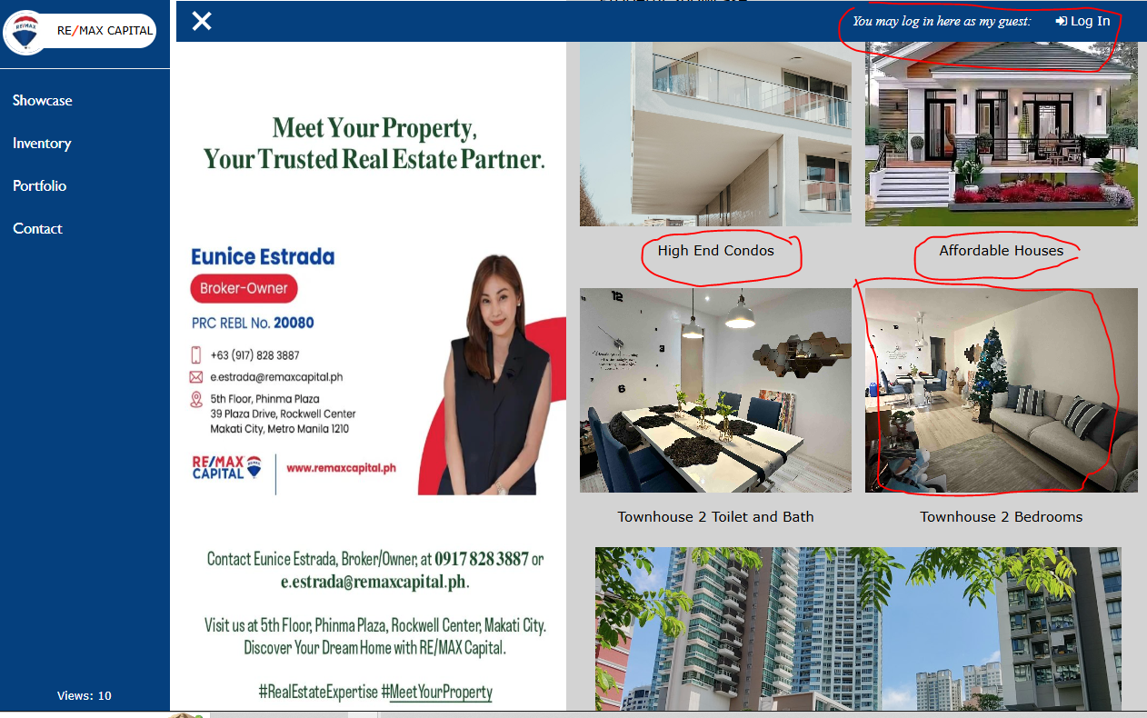

**LOG IN**

The Log In button’s funtion is primarily to make the INVENTORY section updateable. Secondly, if a guest opted to log in his name, it will automatically place the guest name in the CONTACT EMAIL form.

To make the INVENTORY section updateable, you must log in as “siteadmin”.

The “siteadmin” becomes the password that will add additional features to the website.

1. You will notice that a SETTINGS section is added to the Side Bar Menu.
2. Upload Image button is added under each Category Section
3. Add button is added on the Property Listings section.

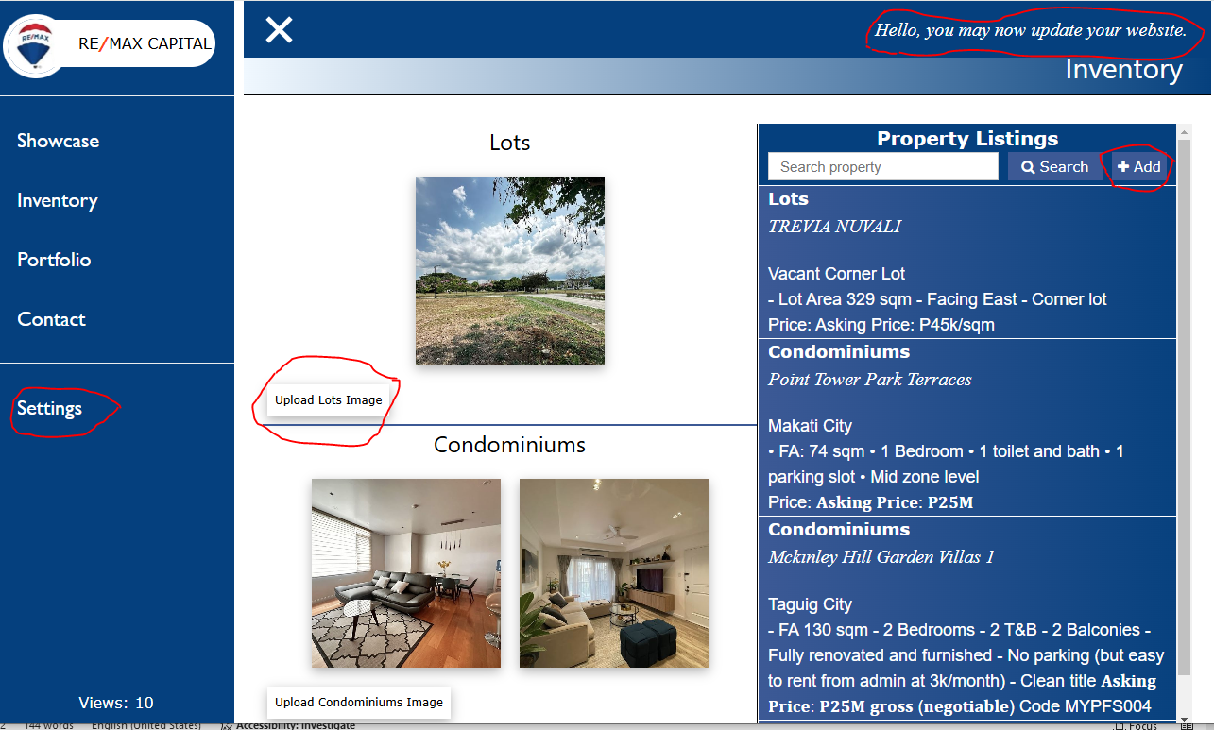

**HOW TO UPDATE THE INVENTORY SECTION:**

Two ways to update the Inventory Section:

1. Click the Upload Image button on the Category panel. (*Left panel of the INVENTORY section*)

**CATEGORIES**

For now, there are only two categories you can select from. (Please s*ubmit any other categories you wish to add*).

On each of these categories you may click on Upload image button to add an image and render the image on the website.

Once an image is uploaded, a form will prompt you to add information about the photo or image. (*Please do not edit the URL address of the uploaded image*) Images here are stored in a cloud database. (*To avail of a free tier account and use of the database,* p*lease limit cloud images to 20 photos only*)

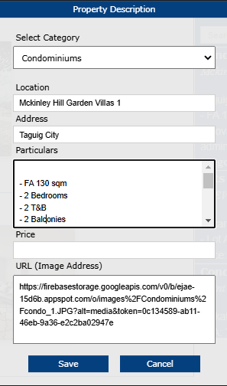

2. Click the +Add button on the Property Listings

**PROPERTY LISTING**

You may add as many property or inventory listing by clicking on the +Add button on the Property Listing panel (*Right side*)

(*List of properties displayed will only show 10 items only so that the page will not get too deep and push the CONTACT section too far below.*)

**SETTINGS**

The SETTINGS section allows you to cusomize your website color theme. You only have 6 theme color to choose from. Just click the color you prefer and Save.

